Practical No:05

Aim: Design and verify half subtactor.

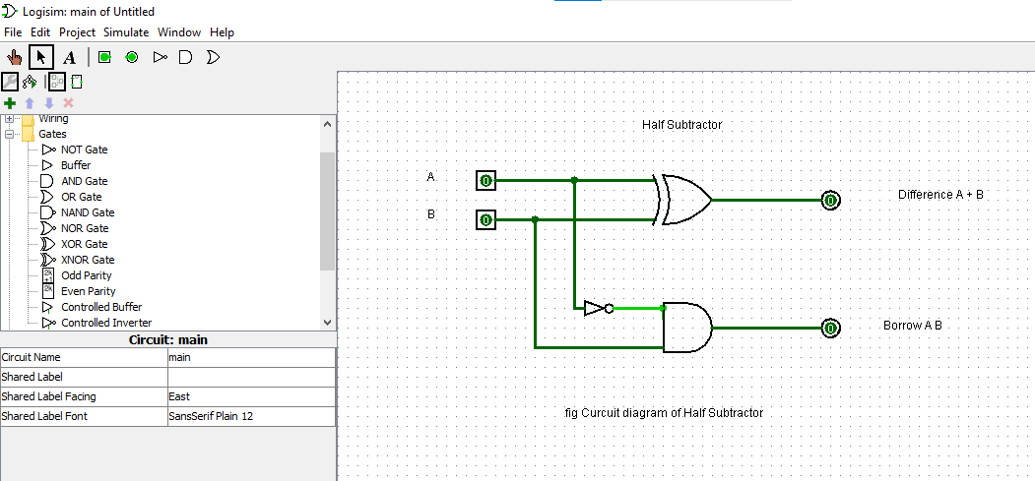

Name: Roshan dhaigude
Sub: Digital System & Architecture
Class:FYBs CS
Roll no:
Sigh

